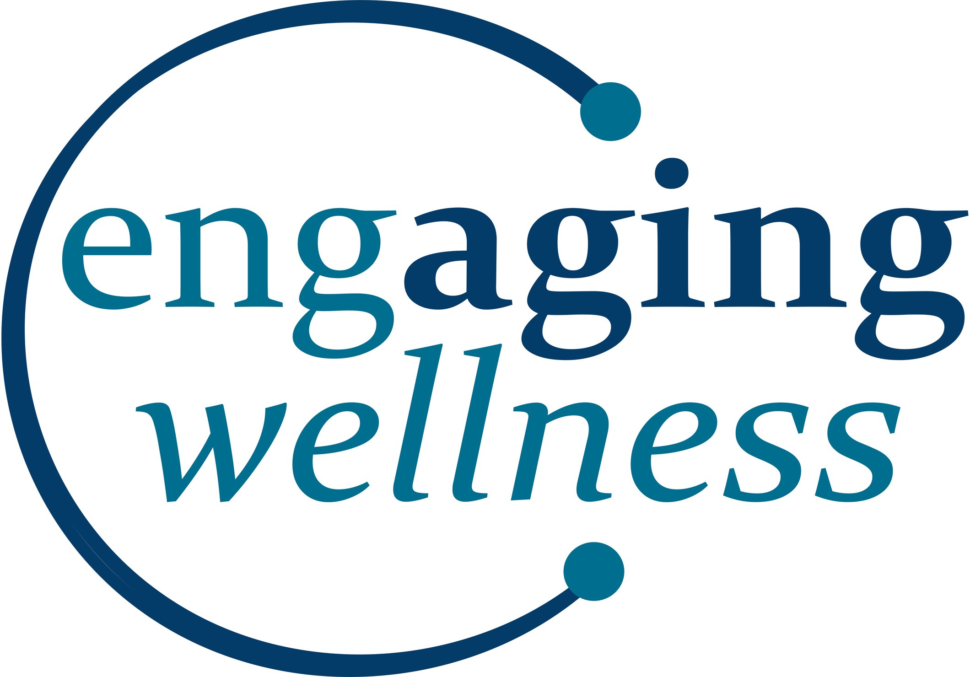




ABOUT ENHANCE FITNESS:
Get one hour of physical activity all while having fun! The EnhanceFitness program is designed specifically for older adults.

FOCUS ON:
muscle strength balance endurance flexibility

For more information, call the Ionia Senior Center (616) 523-5365
FUN!

MONDAY, WEDNESDAY, & FRIDAY:

LOCATION:

Ionia County Commission on Aging
115 Hudson St.
Ionia MI 48846

8:45 am - 9:45 am 10:45am - 11:45 am

Classes Daily

8:45 (M-F) and 10:45 (M-W-F)

Suggested Donation of $2 per class
COST:
JOIN US FOR

A program of the Ionia County Commission on Aging.

