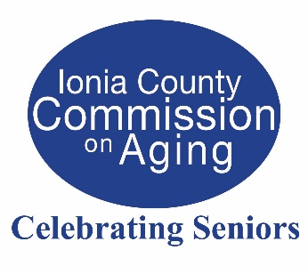
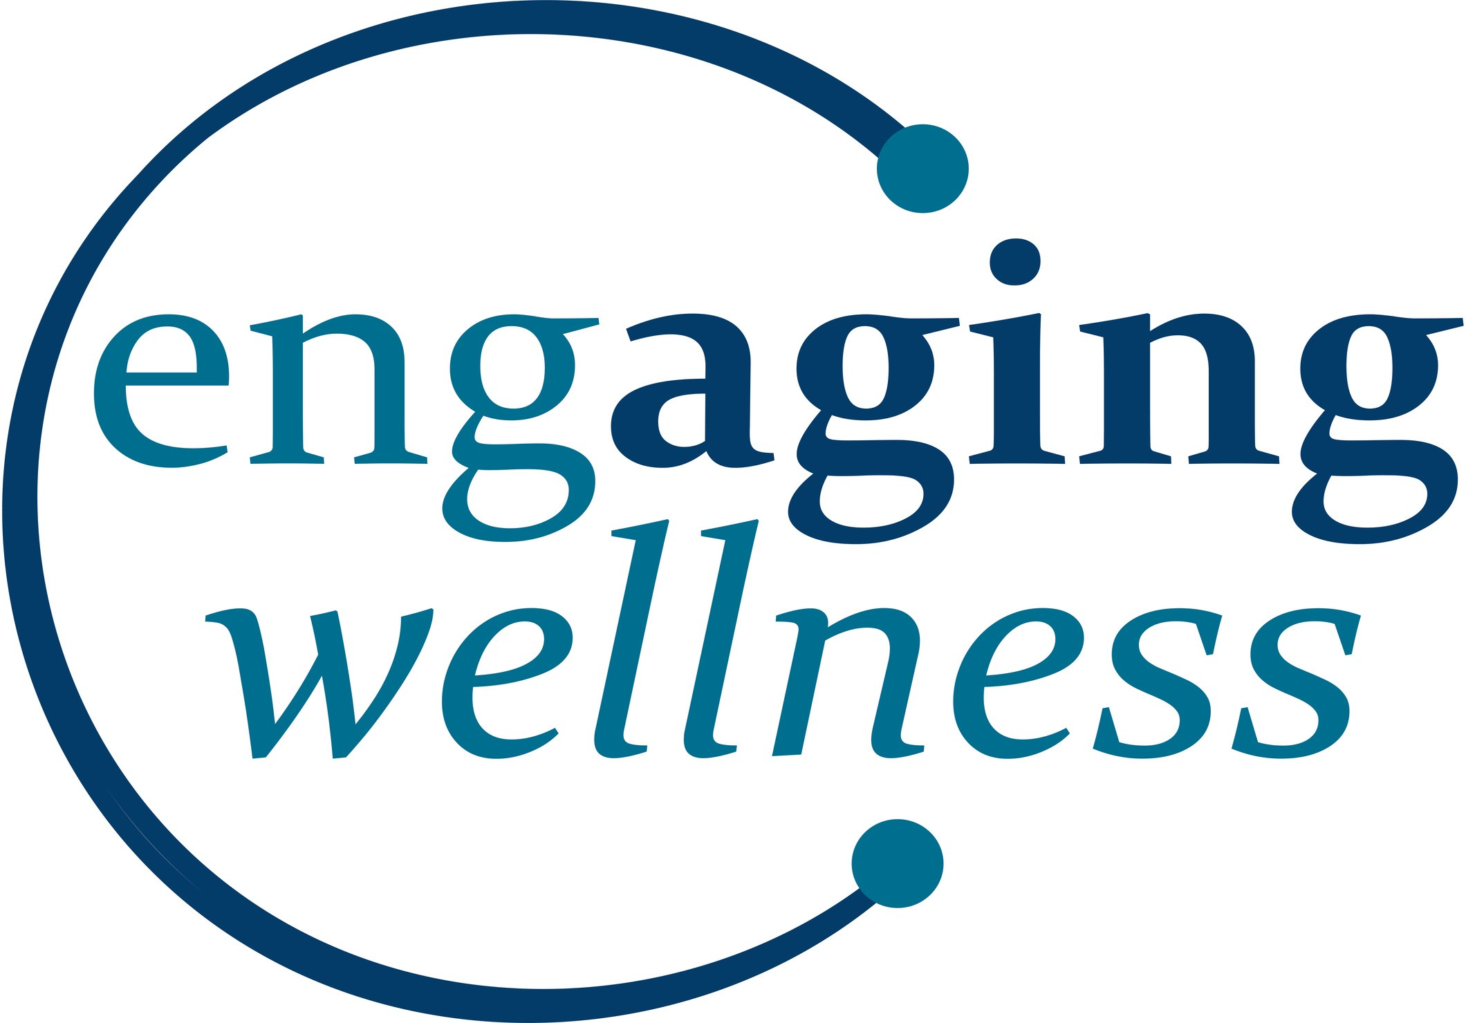
JOIN US FOR
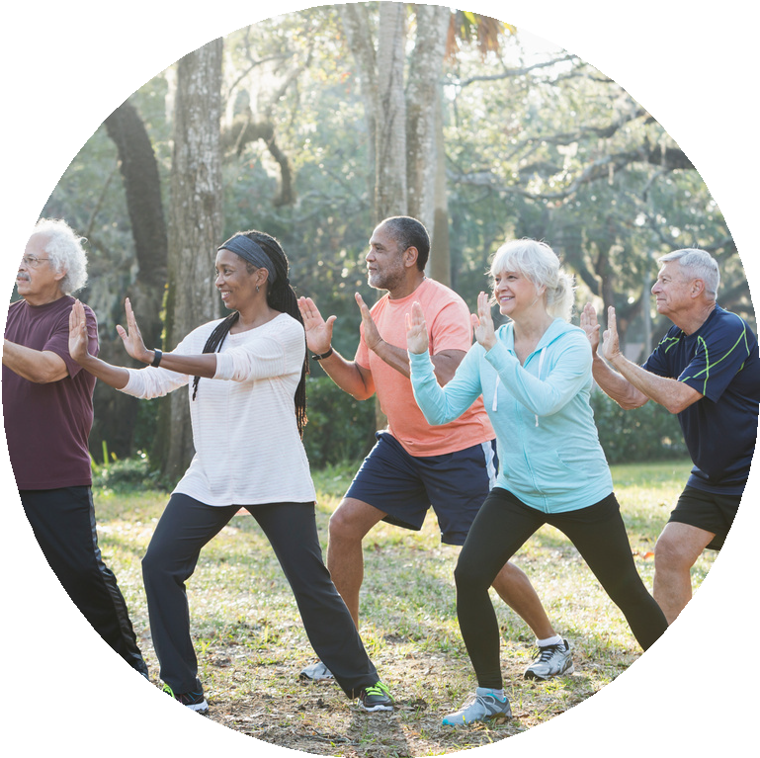
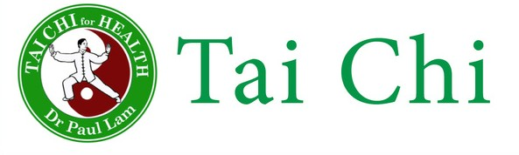

ABOUT TAI CHI:
Tai Chi is a graceful, non-aggressive martial art that helps improve balance, increase flexibility, and improve muscle strength. Each movement builds on the previous to create a smooth, even continuous form.

PROVEN TO:
improve balance reduce falls gain strength
increase flexibility reduce pain
improve mental well-being

LOCATION:

Ionia County Commission on Aging
115 Hudson St.
Ionia MI 48846
Or join us via ZOOM!

SCHEDULE:
Monday, Wednesday & Friday
9:45 am – 10:30 pm

Suggested Donation of $2 per class
COST:

REGISTRATION REQUIRED

For more information, call Ionia County COA
(616) 527-5365 or email ryenchar@ioniacounty.org
A program of the Area Agency on Aging of Western Michigan and the Ionia County Commission on Aging

